1954 Russian Raduga (Rainbow) Field Sequential Color Set
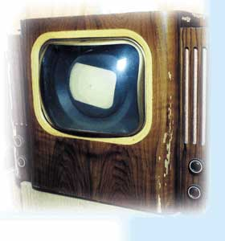
In 1954 Russia built its first color sets. Named "Raduga", which means rainbow, the sets used the field sequential method. This information is from various Russian websites, one of which has a description (in Russian) of the system. The system was experimental, and only a few sets were made. Here are a technical manual and a page describing the set (in Czech). Here are photos of a surviving set at the Popov Museum in St. Petersburg, Russia.
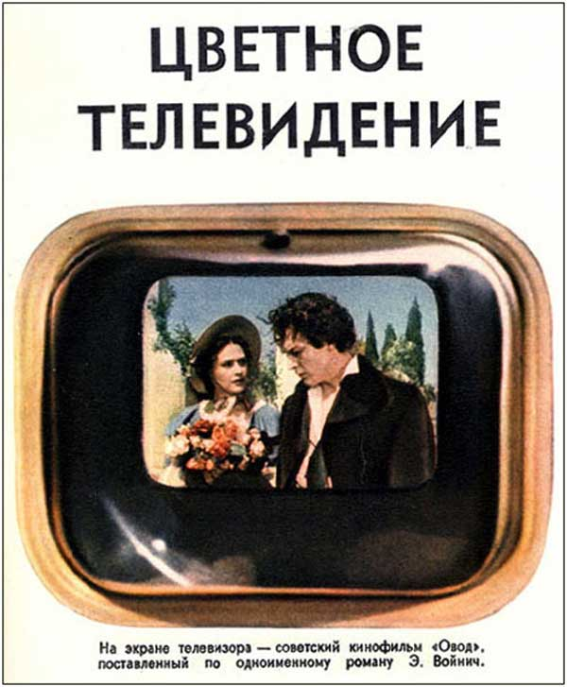
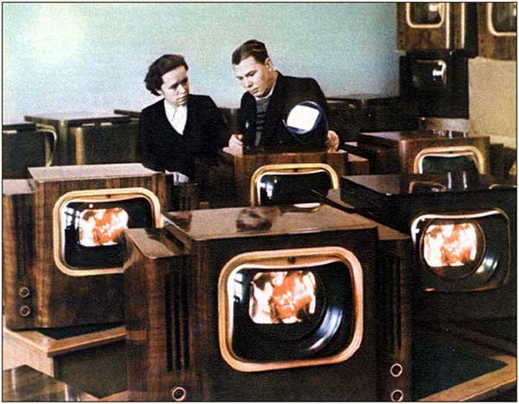
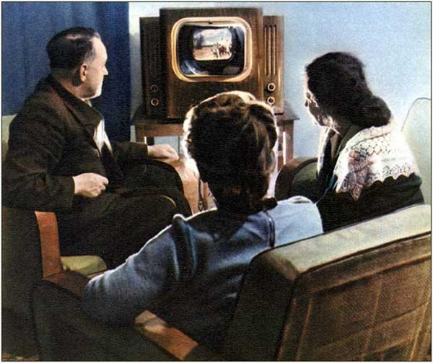
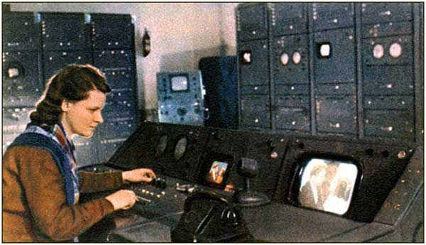

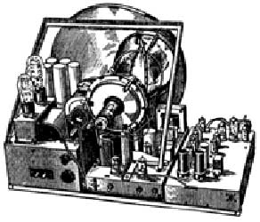 | 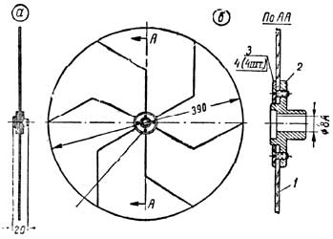
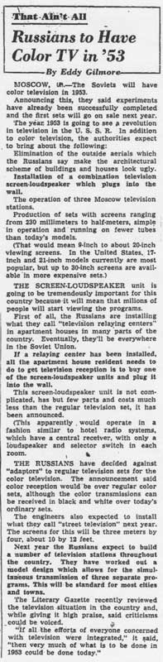
Washington Post, Sept. 11 1952
Courtesy of John Pinckney

